Civil war in Somalia

UNSC Resolution: | 767
Date of adoption: | 24-Jul-1992
Operative paragraph: | 17
Demand number: | 767,1711

Sarah-Myriam Martin-Brûlé

Wording of demand
- cooperate fully with the Secretary-General in the implementation of the present resolution

List of addressees of the demand

Government of Somalia, United Somali Congress Faction

Short-term compliance

Description of the addressee(s)’ conduct

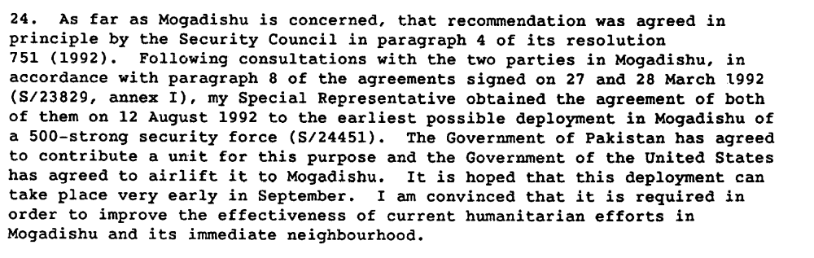

Assessment

Short-term compliance
No or marginal compliance (1) | X Medium low compliance (2) | Medium high compliance (3) | Full or almost full compliance (4)

Considerations underlying the assessment
There was initially compliance with the Secretary-General demand for an agreement. However, the parties failed to comply fully with the implementation of the agreement.

Medium-term compliance

Description of the addressee(s)’ conduct

“That afternoon, the Security Council had met to consider a very pessimistic report on Somalia. The secretary-general wrote that "the situation is not improving" and that conditions were so bad that it would be "exceedingly difficult" for the United Nations' existing operation in Somalia to achieve its objectives. "[I]t may become nec essary," the report said, "to review the basic premises and principles of the United Nations effort in Somalia"?

John Bolton. 1994. “ Wrong Turn in Somalia” , Foreign Affairs, Vol. 73, No. 1 (Jan. - Feb., 1994), pp. 56-66
http://www.jstor.org/stable/pdfplus/20045891.pdf

“Because of conflict at the airport and in light of the CARE ambush, UN officials visited Aidid in an attempt to prevent future ambushes and to keep the humanitarian relief flowing. Aidid denied involvement in the ambush and demanded the immediate withdrawal of the Pakistani troops from the airport. (…)Aidid’s threats immediately drew a sharp rebuke from UN Secretary-General Boutros Boutros-Ghali, who told Aidid that the Pakistani troops would be withdrawn and that if there was bloodshed, he would hold Aidid accountable.”

(…)
“negotiations between the UN and the Somali warlords continued to be meaningless. For example, on November 23 Mahdi promised the UN that he would open Mogadishu’s port to allow food aid ships to dock. Yet the following day, a World Food Program ship was shelled by his forces as it attempted to enter the harbor.
(…)
“On November 27 Boutros-Ghali informed the UNSC that he supported Bush’s decision and the deployment of US military forces under UN auspices because the current UNOSOM efforts were failing.”

Kenneth Rutherford. 2008. Humanitarianism Under Fire: The US and UN Intervention in Somalia. Kumarian Press, p. 69-70

Assessment

Medium-term compliance
X No or marginal compliance (1) | Medium low compliance (2) | Medium high compliance (3) | Full or almost full compliance (4)

Considerations underlying the assessment
In the medium term there was a marginal compliance of the parties to cooperate with the Secretary-General to implement the demands of the resolution.

Depth of demand

Assessment

Level of depth of demand
Low depth of demand (1) | X Medium depth of demand (2) | High depth of demand (3)

Considerations underlying the assessment
Given the insecurity of the setting and the absence of guarantee that the other demand addressee would also comply with this demand, cooperation with military observers (and hence, restrain in using force against their adversaries) could have made it much more difficult for the demand addressee to win the civil war or gain power in its aftermath.

Level of confidence about coding decisions

Level of confidence about coding decision
Extremely high | X High | Moderate

Comments to IPI (if any)

